Victor Adekola

Nana Prempeh

Ctec 298

Section 101

1. Introduction

To start, this complete paper will describe our prior study and look at datasets that we have already collected. With the help of the fact units, we will then be able to generate visualizations and make decisions about our results. Due to the current data that we have access to, our facts and research may now be developed to disclose these remarkable portrayals.The amount and type of information available now far surpasses what can be handled by book analysis and, in certain cases, what can be kept in database systems. Simultaneous to this, networking is widespread, computer power has significantly increased, and techniques to integrate databases have been developed to enable deeper and more thorough study than was previously feasible. In order to demonstrate the resources that we've been able to utilize and start working with the data itself, data sets and tools will be used in our post.

1. Summaries of Ctec 128 papers

a. Summary 1 Group Leader

For Ctec 128 I was able to cover homeowners vs renters to give a brief overview of it the choice between owning or renting a housing unit is crucial and is always determined by numerous factors, such as economic, social, and environmental factors. Currently, housing units constitute a significant portion of most households' wealth in many countries across the world. Therefore, a household's choice of unit choice has a critical effect on the economy. Homeowners can either buy a house or can have it purchased through a mortgage. Homeowners pay a monthly mortgage to settle the secured loan. Homeowners have the opportunity of personalizing or decorating their homes according to their tastes. Besides, the housing unit owner can decide either to increase or decrease the value, especially when they want to sell.

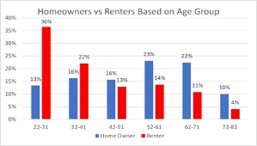

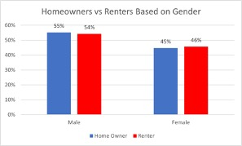

b. Summary 2 member 1

For my 128 paper I covered how stereotypes affect black students and how they are more prone to get into school trouble than other demographics. In this paper I highlight the racial inequalities in teacher-issued office punishment referrals are less well-documented than the suspension gaps. Referrals for discipline, such as suspension, might result in lost instructional time. Although kids are sent out of the classroom for a variety of reasons, Black children are more likely than other groups to be sent out. The overrepresentation of black pupils on suspension lists in schools is unquestionably concerning.As new evidence reveals, incarceration has a detrimental influence on high school completion, suspension can lead to dropout. Low accomplishment, dropout, and delinquency have all been connected to future economic challenges, notably in the labor market, as a result of suspension. Even if the above-mentioned links between suspension and future results aren't totally causal, the presence of racial bias in the application of discipline in public schools is still significant. First, critics of out-of-school punishment frequently point to racial inequity as one of the key reasons for reconsidering the policy. there is a need to raise teacher awareness about negative racial beliefs and the conditions under which those beliefs impact decision-making during discipline incidents. We further point out the need to foster teacher awareness about the power of positive beliefs in affecting student outcomes and the malleability of beliefs and disciplinary practices through intervention.

III. Description of Ctec materials submitted

a. Description 1 Group Leader

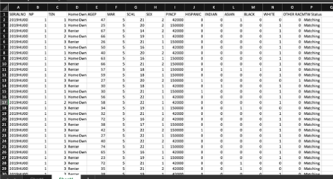

An Excel spreadsheet was used to arrange and tidy the data for this table. The spreadsheet's redundant data types were eliminated to make it simpler to edit and create graphs. When using Jupyter Notebook, we may import the matplotlib library. Usually any one of the six graphs, such as a bar graph or pie chart, can be utilized to graphically represent the data once the import is finished.

b. Description 2 Member 1

In order to find out whether the stereotype that black students often get into school issues and disciplinary actions more than whites, to complete this data was used from the CRDC database using data from 2017-2018. The Civil Rights Data Collection (CRDC) is a biennial (i.e., every other school year) survey required by the U.S. Department of Education’s (Department) Office for Civil Rights (OCR) since 1968. The plotted by using the spreadsheets and crdc website below

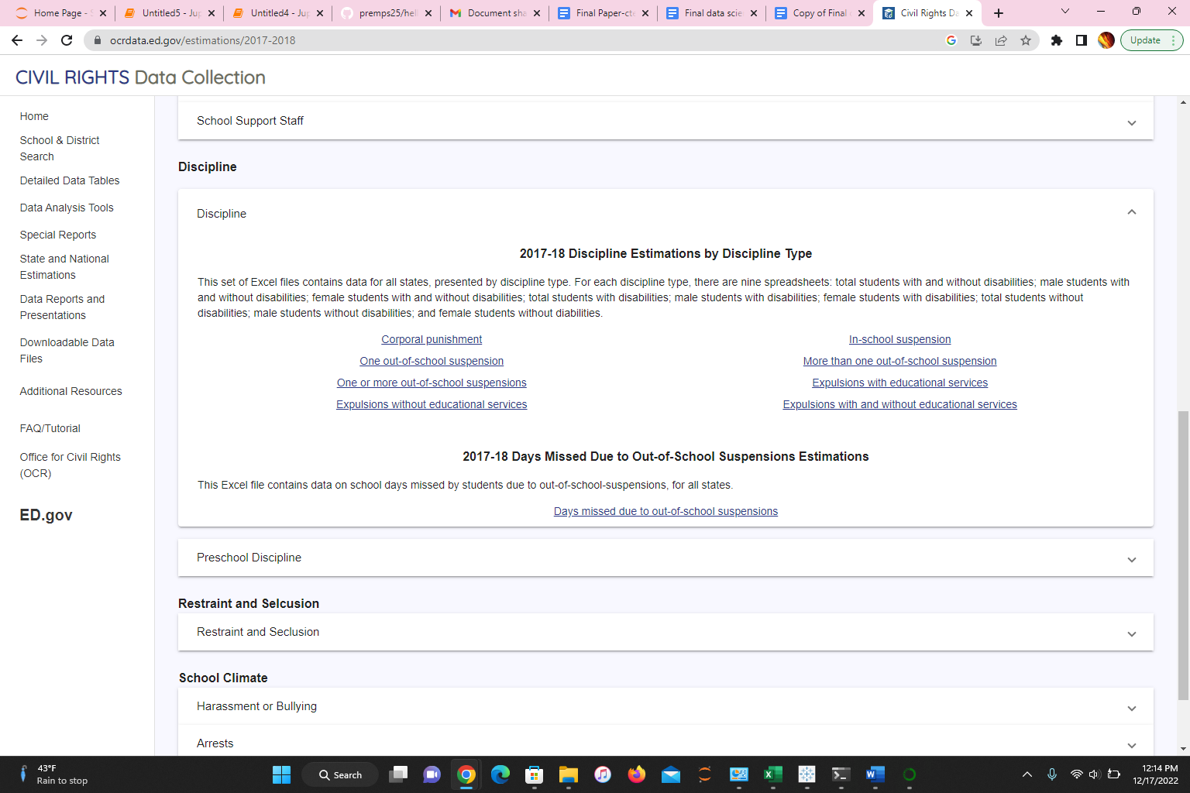

IV. Description of the plot deliverables

a. Description 1 Group Leader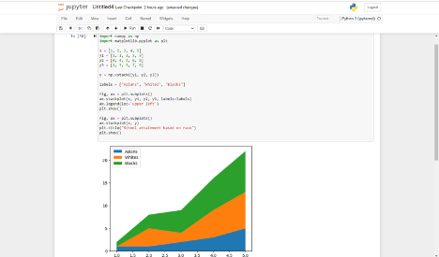

The movement toward homeowners and renting is also affected all levels of educational achievement. Ideally, from 2006 to 2019, rental rates have been increased among many people headed with someone who did not finish high school. College graduates tend more towards renting instead of owning housing units. The holders of Bachelor's Degree has 31% as a homeowner and renting at 30%. The margin is close; the homeowner is higher than renting.

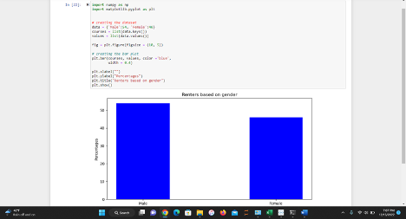

There is a significant difference based on gender. The male gender seems to be more prevalent than the female gender in both homeownership and renting. Males have 55% for homeownership and 54% for renting. At the same time, females have 46% for rental and 45% for homeownership.

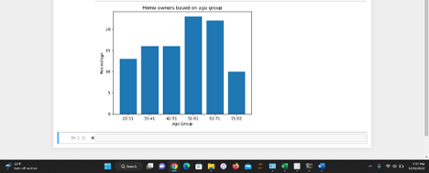

About 36% of households preferred renting, and they are people who are between the ages of 22-31. They are followed by individuals under the ages of 32 and 41 in renting housing units, especially when they stay. On the other hand, individuals owning houses stand at 23%, and the majority of these people fall under the age bracket of 52-61. Python code: import matplotlib.pyplot as plt

age_group = ['22-31', '32-41', '42-51', '52-61', '62-71', '72-82']

percentage = [13,16.16,23,22,10]

plt.bar(age_group, percentage)

plt.title('Home owners based on age group')

plt.xlabel('Age Group')

plt.ylabel('Percentage')

plt.show()

b. Description 2 member 1

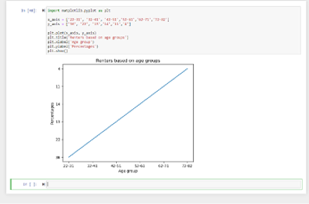

About 36% of households preferred renting, and they are people who are between the ranges of 22-31. They are followed by individuals under the age of 32 and 41 in renting housing units, especially when they stay. On the other hand, Individuals owning houses stand at 23%, and the majority of these people fall under the age bracket of 52-61

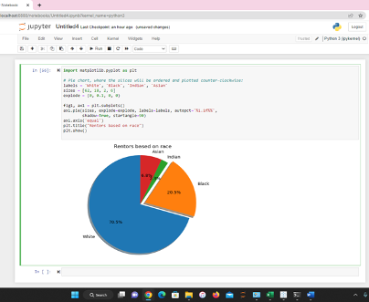

Black and Hispanic individuals have about twice as likely as white people to rent their housing units. Whites lead in both homeowners and renters with 77% and 62%. These statistics could be different and most important when major racial and ethnic groups can rent housing units. Therefore, an increase in the rental rates will affect several families.

V. Summary/conclusion

The data visualizations can be used to build some conclusions about the data. After considering the data, it can be concluded that 60-70% were White and the rest of the categories making up that remaining 30%. The biased representation of this data is a concern. It must be quickly addressed rather than put aside, because if data is not processed correctly and accurately, it is still just information. Due to this, we cannot be 100% sure the correlations, lower instances of income, and the rest of the data wrangling is accurate. Overall, it would be safe to say there are more renters in the age group 22-31 as compared to the others and more homeowners in the age group 52-61 as compared to the rest of the age groups, more male homeowners and renters as compared to the opposite sex and also people who have attained a bachelor’s degree tend more to be homeowners and renters.Also based on this data and plots you can get a sense of how the data will be interpreted and how it will be displayed on various types of graphs and charts to be ale to give the data multiple ways to be properly understood by others. It is ultimately up to individual circumstances and personal preferences as to whether it is better to be a homeowner or a renter. Some of the factors that may influence this decision include financial considerations, stability and flexibility, and personal values and priorities.

For some people, owning a home may be a financial investment that can build wealth over time through appreciation and the potential for tax benefits. It can also provide a sense of stability and a sense of ownership and control over one's living situation. However, homeownership also involves a significant financial commitment, including the cost of a down payment, closing costs, maintenance and repairs, and property taxes. It can also be more difficult to move or make changes to your living situation when you own a home.

On the other hand, renting may offer more flexibility and freedom, as it usually requires a smaller financial commitment upfront and may be more suitable for those who are not ready to commit to a long-term living situation or who may need to move frequently. Renters also typically do not have to worry about maintenance and repairs, as these responsibilities typically fall to the landlord. However, renters do not have the same level of ownership and control over their living situation and may not benefit from the potential financial appreciation of a property.

References

Lewin, T. (2012). Black students face more discipline, data suggests. The New York Times.

Kinsler, J. (2011). Understanding the black–white school discipline gap. Economics of Education Review, 30(6), 1370-1383.

Blake, J. J., Smith, D. M., Marchbanks, M. P., Seibert, A. L., Wood, S. M., & Kim, E. S. (2016). Does student–teacher racial/ethnic match impact Black students’ discipline risk? A test of the cultural synchrony hypothesis. In Inequality in school discipline (pp. 79-98). Palgrave Macmillan, New York.

CRDC datasets

Bijlsma, M., &amp; Mocking, R. (2017). The impact of house price shocks on dutch homeowners

and renters (No. 346. RDF). CPB Netherlands Bureau for Economic Policy Analysis.

Brunner, E. J., Ross, S. L., &amp; Simonsen, B. K. (2015). Homeowners, renters, and the political

economy of property taxation. Regional Science and Urban Economics, 53, 38-49.

Diamond, R., Guren, A., &amp; Tan, R. (2020). The effect of foreclosures on homeowners,

tenants, and landlords (No. w27358). National Bureau of Economic Research.

VI. References

Bijlsma, M., &amp; Mocking, R. (2017). The impact of house price shocks on dutch homeowners

and renters (No. 346. RDF). CPB Netherlands Bureau for Economic Policy Analysis.

Brunner, E. J., Ross, S. L., &amp; Simonsen, B. K. (2015). Homeowners, renters, and the political

economy of property taxation. Regional Science and Urban Economics, 53, 38-49.

Diamond, R., Guren, A., &amp; Tan, R. (2020). The effect of foreclosures on homeowners,

tenants, and landlords (No. w27358). National Bureau of Economic Research.

Hankinson, M. (2018). When do renters behave like homeowners? High rent, price anxiety,

and NIMBYism. American Political Science Review, 112(3), 473-493.